Marketing Plan - Sections

* Executive Summary
* Target Customers
  + Developers
  + Students
  + "Fixers"
* Distribution Plan
  + The plan will be to first give it to the carleton library
  + From there be brought to the developers that want it to create something
  + We will be going to the computer science, and engineering departments to try and get students to use the API when it is done
* Your Offers
  + Kinect and motion data collection
  + Very cool interface
* Marketing Materials
  + Described below
* Promotions Strategy
  + Described below
* Online Marketing Strategy
* Conversion Strategy
* Joint Ventures & Partnerships
* Referral Strategy
* Strategy for Increasing Transaction Prices
* Retention Strategy

The aspects of our marketing plan will include a website, poster, info cards, videos, and a live demo of the example game in the 4th floor atrium.

Developers love stickers so I will try to get some stickers of reactive spaces or work in progress. Both would be nice.

Stickers - <http://www.stickeryou.com/stickeryou/designyourownstickers.aspx>

The website will be our main marketing platform. It will house the videos, tutorials, API, and the information towards the API.

Having the website being the main campaign, There are some aspects that are needed on the website to make it look great while showing the needed information. The future of UX design have some elements:

* Engaging Typography
  + Ex Mixd website. Beautifully organized

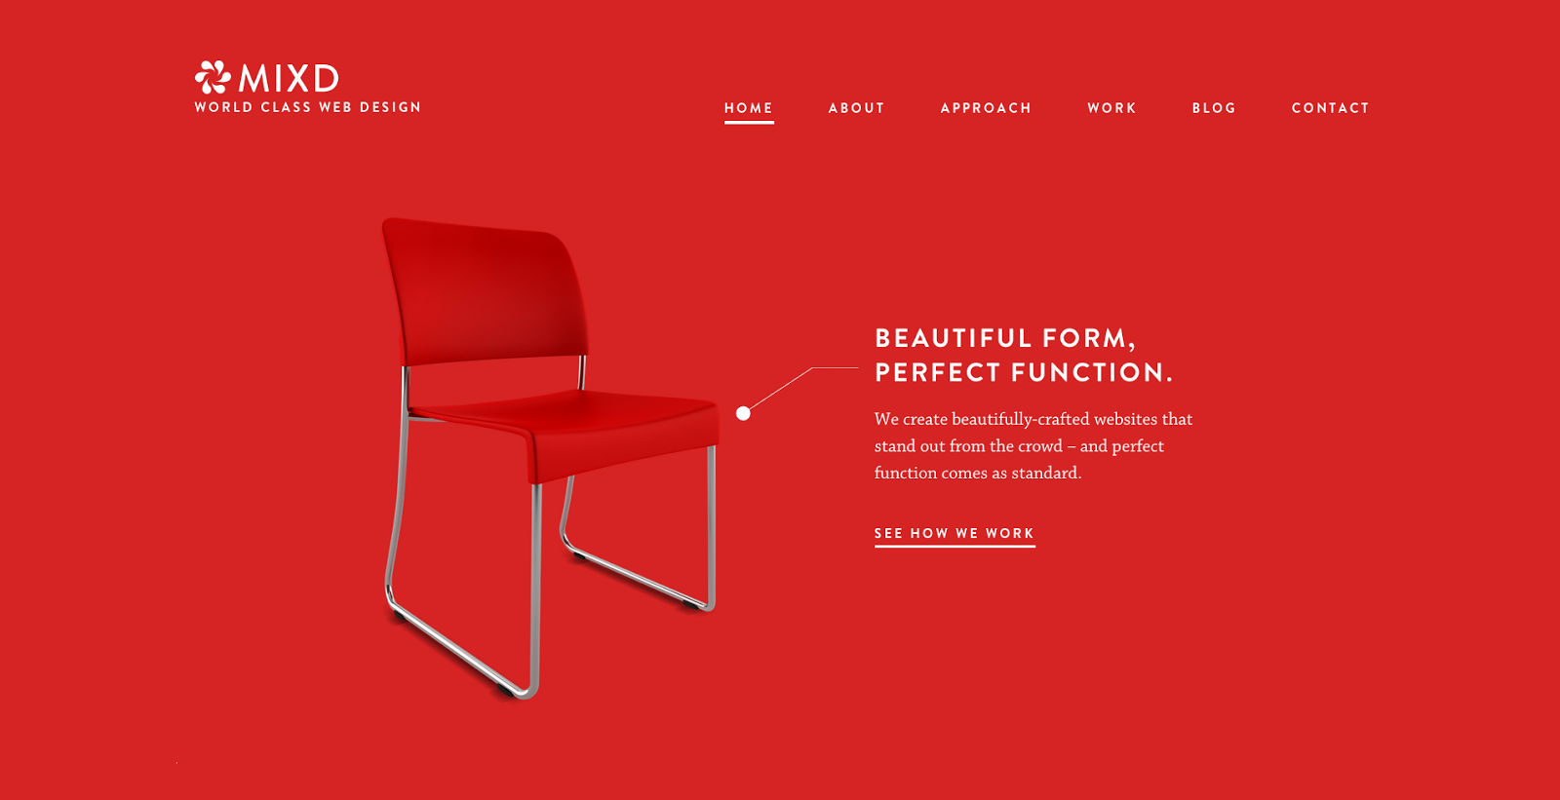

* Mobile accessibility
* Less Text, Larger Images
  + Most software websites, developer websites
  + Ex. Slack Website

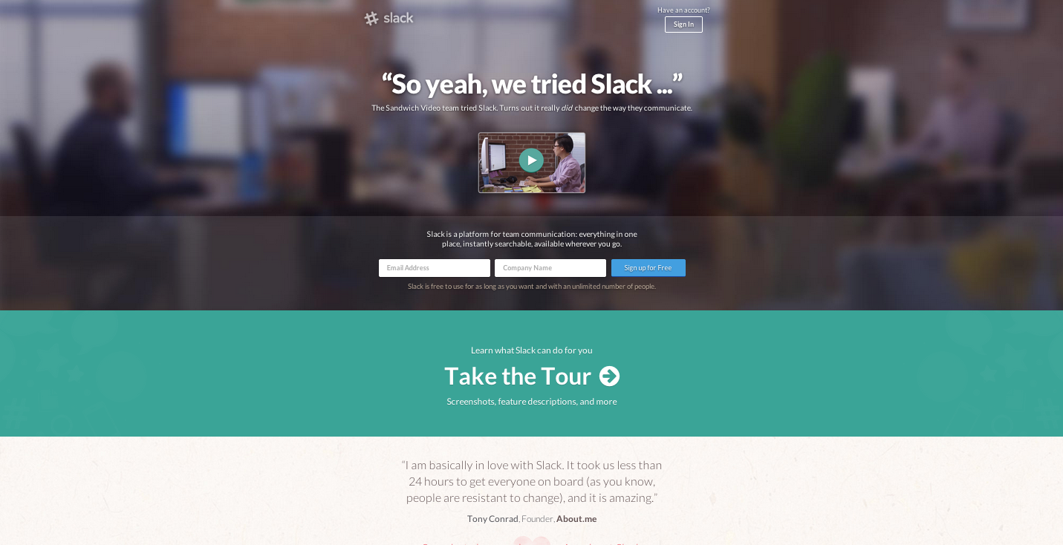

* Scroll Initiated Animation
* Flat User interface
* Minimalism
  + Ex. HUGE website

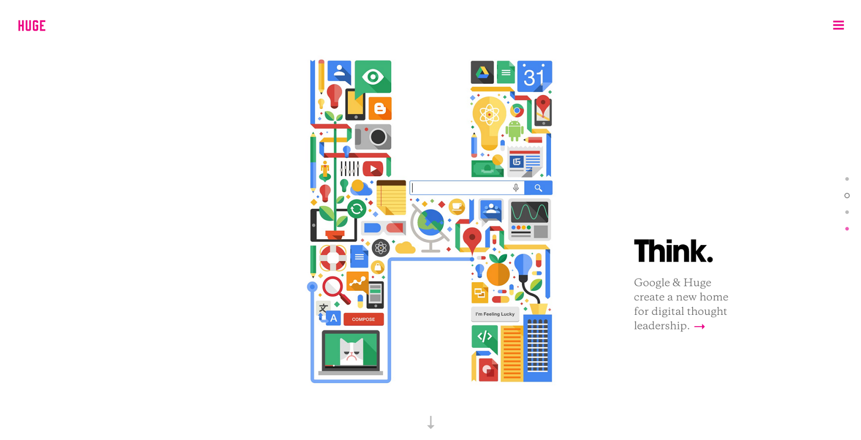

Reference websites:

Slack - <https://slack.com/>

three.js - <http://threejs.org/>

HUGE - <http://www.hugeinc.com/>

Mixd - <http://www.mixd.co.uk/>

Two sided website -

Velvethammer - <http://velvethammer.net/>